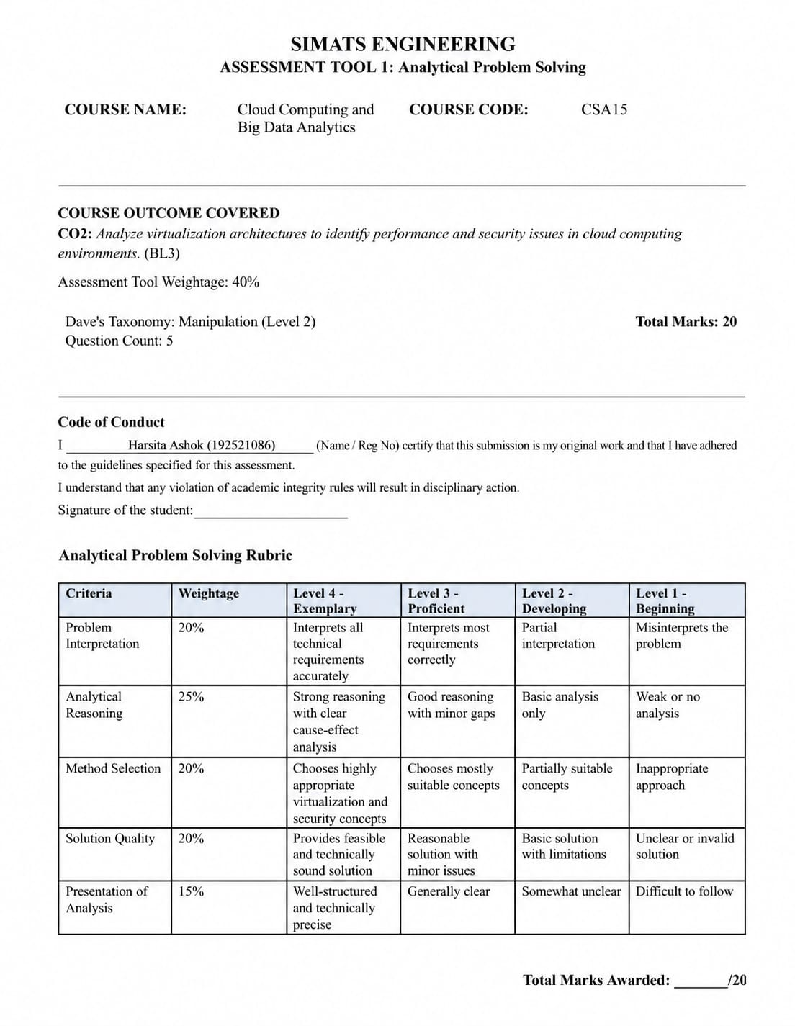

Name: Harsita Ashok
Reg No: 192521086
CSA1507 Cloud Computing and Big Data Analytics
CO2 AT1 Analytical Questions

Q1 (10 Marks): A multinational company plans to build a cloud data center serving millions of users. Design the cloud data center architecture with appropriate components.
= A cloud data center is a facility that provides computing resources such as servers, storage, networking, and cloud services over the internet. For a multinational company serving millions of users, the architecture must be scalable, secure, highly available, and fault tolerant.
Cloud Data Center Architecture
Internet Users
│
DNS / Load Balancer
│
Firewall / WAF
│
API Gateway / Gateway
│
┌────────────────────────────────────┐
│ Application Servers (VMs) │
│ Containers / Kubernetes │
└────────────────────────────────────┘
│
┌───────────────┴───────────────┐
│ │
Database Cluster Storage System
(SQL / NoSQL Databases) (Object, Block, File Storage)
│ │
└───────────────┬───────────────┘
│
Backup & Disaster Recovery
│
Monitoring & Management
Components of the Architecture
1. Internet Users
- Users access cloud services through web browsers or mobile applications.
- Requests are sent to the nearest cloud data center.
2. DNS (Domain Name System)
- Converts domain names into IP addresses.
- Directs users to the closest or healthiest server.
3. Load Balancer
- Distributes incoming traffic among multiple servers.
- Prevents server overload.
- Improves response time and availability.
4. Firewall / Web Application Firewall (WAF)
- Protects the data center from cyber attacks.
- Filters malicious traffic.
- Prevents SQL injection, DDoS, and other attacks.
5. API Gateway
- Receives all client requests.
- Performs authentication and request routing.
- Controls access to cloud services.
6. Application Servers
- Run business applications and web services.
- Hosted on Virtual Machines (VMs) or Containers.
- Automatically scale according to demand.
7. Database Cluster
- Stores application data.
- Includes SQL and NoSQL databases.
- Uses replication for high availability.
8. Storage System
Provides different storage services:
- Object Storage – Images, videos, backups.
- Block Storage – Virtual machine disks.
- File Storage – Shared files among applications.
9. Backup and Disaster Recovery
- Creates regular backups of important data.
- Restores services quickly after failures.
- Uses replication across different regions.
10. Monitoring and Management
- Continuously monitors servers, storage, and networks.
- Detects failures automatically.
- Generates alerts and performance reports.
Features of the Architecture
- High scalability
- High availability
- Fault tolerance
- Strong security
- Automatic resource allocation
- Disaster recovery support

Q2 (10 Marks): Analyze how redundancy improves the reliability of cloud data centers. give detail answers
= Redundancy means having duplicate or backup components in a cloud data center. If one component fails, another immediately takes over without interrupting the service. Redundancy is one of the most important techniques for achieving high reliability and continuous availability.
Types of Redundancy
1. Server Redundancy
- Multiple servers perform the same task.
- If one server fails, another server continues processing requests.
- Ensures uninterrupted service.
2. Storage Redundancy
- Data is stored in multiple disks or storage systems.
- Technologies such as RAID and data replication protect against disk failures.
- Prevents data loss.
3. Network Redundancy
- Multiple network switches, routers, and communication links are used.
- If one network path fails, traffic is automatically redirected.
- Reduces network downtime.
4. Power Redundancy
- Uses Uninterruptible Power Supply (UPS), backup generators, and multiple power feeds.
- Keeps the data center running during power failures.
5. Database Redundancy
- Copies of databases are maintained on multiple servers.
- If the primary database fails, a replica takes over.
- Ensures continuous access to data.
6. Geographic Redundancy
- Data and applications are replicated across multiple data centers in different regions.
- Protects against natural disasters and regional outages.
- Enables disaster recovery.
Benefits of Redundancy
- Improves system reliability.
- Minimises downtime.
- Prevents data loss.
- Provides fault tolerance.
- Supports business continuity.
- Increases customer satisfaction.
- Ensures high availability (24×7 service).
Example
A cloud provider hosts an online shopping application on three application servers connected through a load balancer. If one server fails due to hardware issues, the load balancer automatically redirects traffic to the remaining servers. Users continue shopping without noticing any interruption. Similarly, database replicas ensure that customer data remains available even if the primary database fails.
Advantages
- Continuous service availability.
- Faster recovery from failures.
- Better fault tolerance.
- Improved performance through load sharing.
- Increased user trust and reliability.
Disadvantages
- Higher infrastructure cost.
- Increased power and storage requirements.
- More complex management and maintenance.

